8 YEPI Partner Institutions Meet in Cape Town

In November 2013, the Talloires Network Secretariat convened an opening workshop for the eight universities participating in the Youth Economic Participation Initiative. This initiative, launched in 2012 with support from The MasterCard Foundation, supports the work of eight Talloires Network institutions that are implementing innovative strategies to facilitate their students’ transition from university to employment and entrepreneurship.

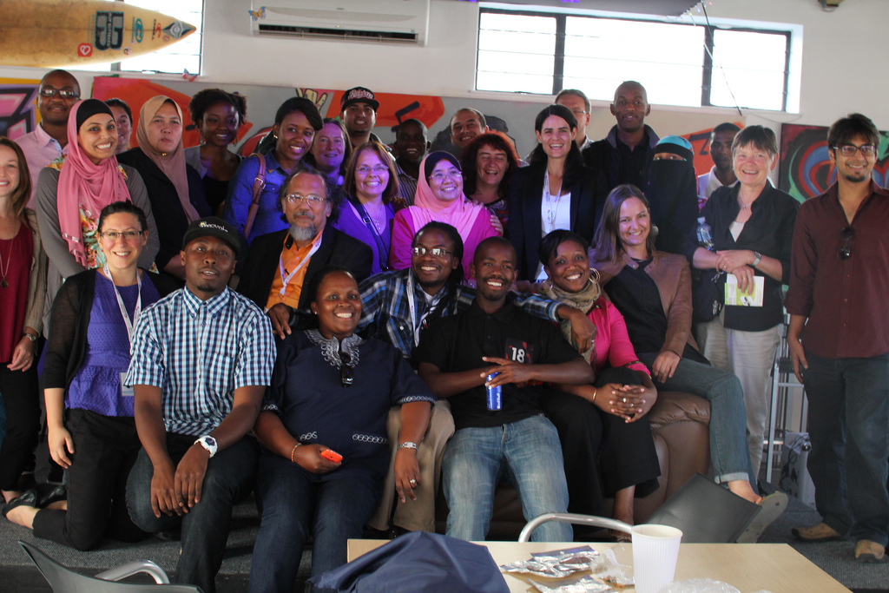

YEPI Partner Institution Leaders and TN Staff with Young Entrepreneurs

Eighteen representatives from these YEPI partner universities met in Cape Town, South Africa the week of November 18th to kick off the Youth Economic Participation Initiative. Participants learned about each others’ work, discussed the goals and vision of the Youth Economic Participation Initiative, and began to develop a common framework for learning, monitoring and evaluating their efforts.
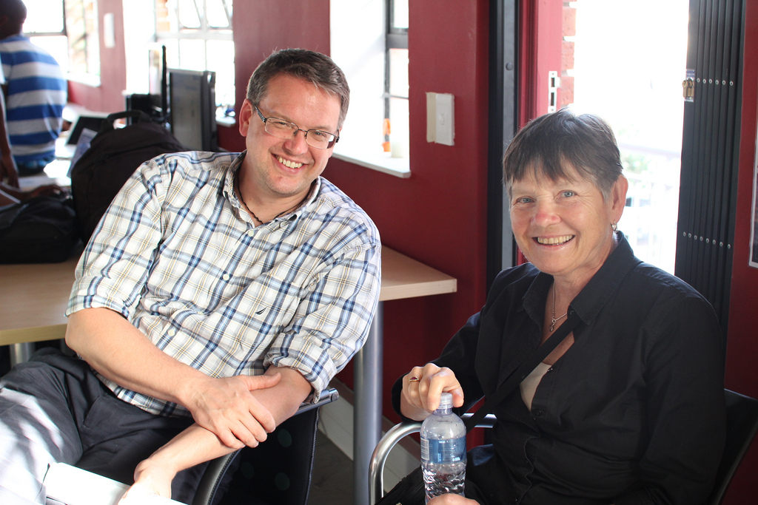
In support of the learning agenda for the YEPI, two professors from the University of Minnesota also joined the workshop. Drs. Carol Carrier and Ross VeLure Roholt represent a highly experienced team that will assist the Talloires Network and YEPI partner institutions to learn, monitor and evaluate within and across their programs.
YEPI Learning Partners

Many thanks to the accomplished leaders who joined us in Cape Town:

Elodie Hanff, Project Director for Promoting science-based social entrepreneurship in Africa, International Institute for Water and Environmental Engineering, Burkina Faso

Sarah Ouedraogo, Corporate Partnerships Officer, International Institute for Water and Environmental Engineering, Burkina Faso

Maryam Mohiuddin Ahmed, Co-Founder and Project Director, Literaty Pakistan, Lahore University of Management Sciences, Pakistan

Asad Ayub, Co-Founder and Project Trainer, Literaty Pakistan, Lahore University of Management Sciences, Pakistan
Mohd Fauzi Mohd Jani, Director of the Centre for Entrepreneurship and SMEs Development, National University of Malaysia
Rosilah Hassan, Assoc. Prof. and Deputy Director, Centre for Entrepreneurship and SMEs Development, National University of Malaysia
Aini Aman, Assoc. Prof. and Deputy Director, Centre for Entrepreneurship and SMEs Development, National University of Malaysia
Ester Fecci, Head of Project and Coordinator of Activities for Faculty Training, Universidad Austral de Chile
Patricio Belloy, Coordinator of International Relations, Universidad Austral de Chile
Caroline Ryan, Programme Manager, Solve the Equation East Africa, National University of Rwanda, Nyagatare

Elli Yiannakaris, Director of Raymond Ackerman Academy and Coordinator of the Graduate Entrepreneur Support Services, University of Cape Town Graduate School of Business
Wajdi Abrahams, Advisor for the Graduate Entrepreneur Support Services, University of Cape Town Graduate School of Business

Nareeman Africa, RAA and Bertha Centre Administrator, University of Cape Town Graduate School of Business

Clíona Maher, Coordinator of International Cooperation, International Office, Universidad Veracruzana

Begoña Arreche Irigoyen, Manager for Engagement Program with the Productive Sector, Universidad Veracruzana

Donald Bodzo, Executive Director PaNhari Program, University of Zimbabwe

Tinotenda Pasi, Resource Development Officer PaNhari Program, University of Zimbabwe

Takawira Kapikinyu: Monitoring and Evaluation Specialist PaNhari Program, University of Zimbabwe

We look forward to sharing more about the innovative work of each YEPI partner university in the months ahead. Please look for the official launch of the global community of practice in 2014, and consider ways you might share the work of your own institutions. We know many Talloires Network members are involved in similarly exciting and transformational initiatives!

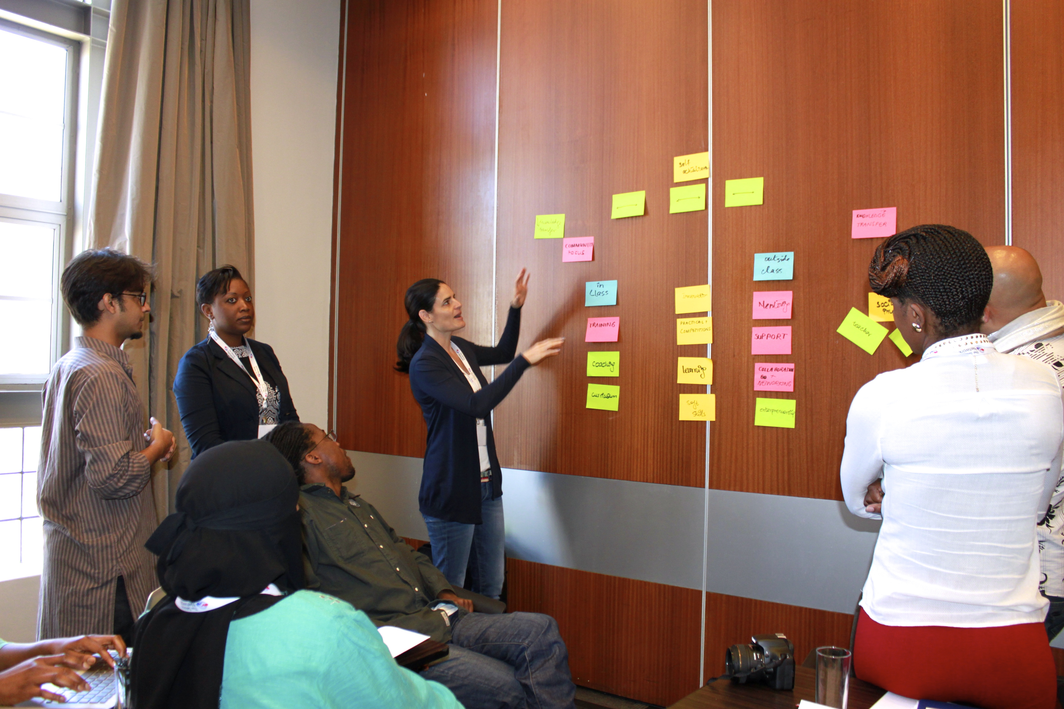
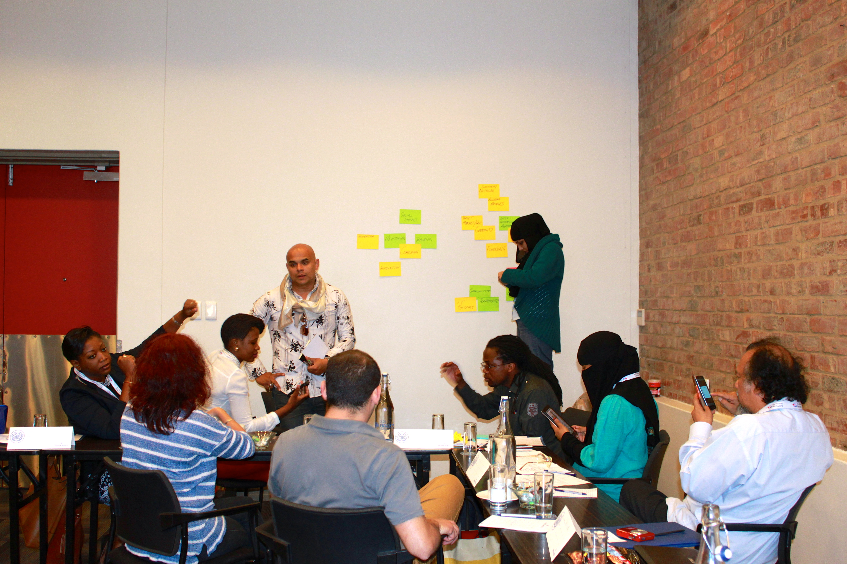
Above and below: Leaders from YEPI Partner Institutions share ideas and work together in small groups

